I used an NG Prime template to make my front-end development easier: <https://github.com/primefaces/sakai-ng>. Additionally, I streamlined the code for the application's main routes, which include:

* Dashboard/
* Uikit/list/
* Auth/login/
* Auth/disconnect/
* Page/empty/ "idOfQuestion"

I also added error handling routes:

* Notfound/

Certain routes are only accessible when logged in, such as:

* Dashboard/
* Page/empty/ "idOfQuestion"

This condition is managed by various modules that I added, including:

* Guard
  + Manages whether the user can access the requested page.
* Interceptors
  + Intercepts all requests made by the application and adds the "Authorization" header.
* Services
  + Answer
  + Auth
  + Question
  + Tags
* Models
  + Answer
  + Question
  + Tags
  + User

Architecture :

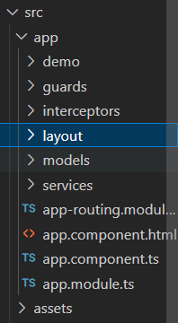

In the demo folder you have all necessary component for the application:

